**DIGITAL FORENSICS LAB**

|  |  |
| --- | --- |
| Exercise 9 | |
| Name | S Shyam Sundaram |
| Registration Number | 19BCE1560 |
| Slot | L39+L40 |
| Faculty | Dr. Seshu Babu Pulagara |
| Date | 12th October, 2021 |

**AIM**

Comparing file types and signatures with Hex editors to identify what type of file they are originally.

**PROCEDURE AND OBSERVATIONS**

**Q**

Download at least two files with each of the following extensions from the Internet and keep them in a folder: jpg, png, bmp, gif, pdf

Use a hexadecimal editor such as Winhex (see https://www.x-ways.net/winhex/ ) or some other hexadecimal editor (see https://en.wikipedia.org/wiki/Comparison_of_hex_editors ) to look at the hexadecimal contents of the file in order to find headers and footers. Check whether headers and footers are the same for the same file type.

**A**

We use 4 files: one.jfif, two.png, three.pdf and four.gif. They are shown below:



two.png

One.jfif

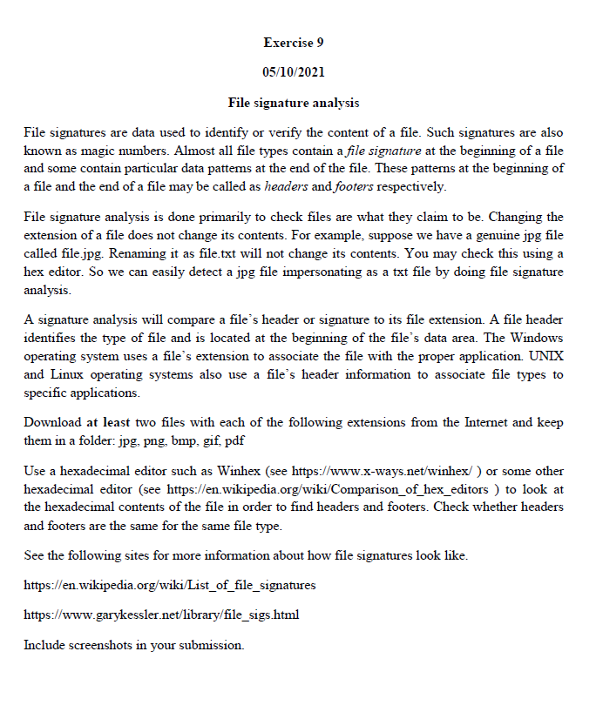

four.gif

three.pdf

We now change their extensions to: one.txt, two.pdf, three.jpg and four.mp3.

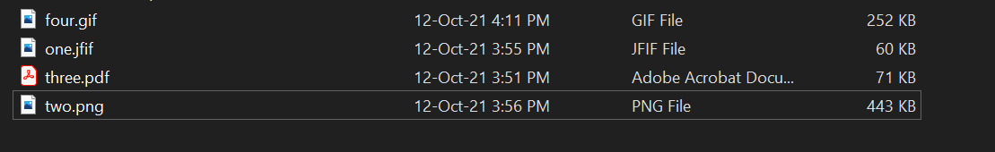

Before

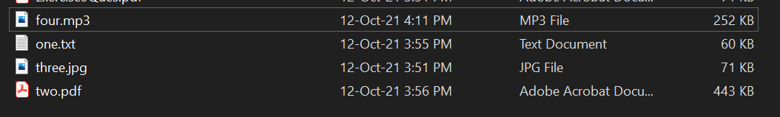

After

We now open these files in WinHex and see their contents.

**One.jfif/.txt**

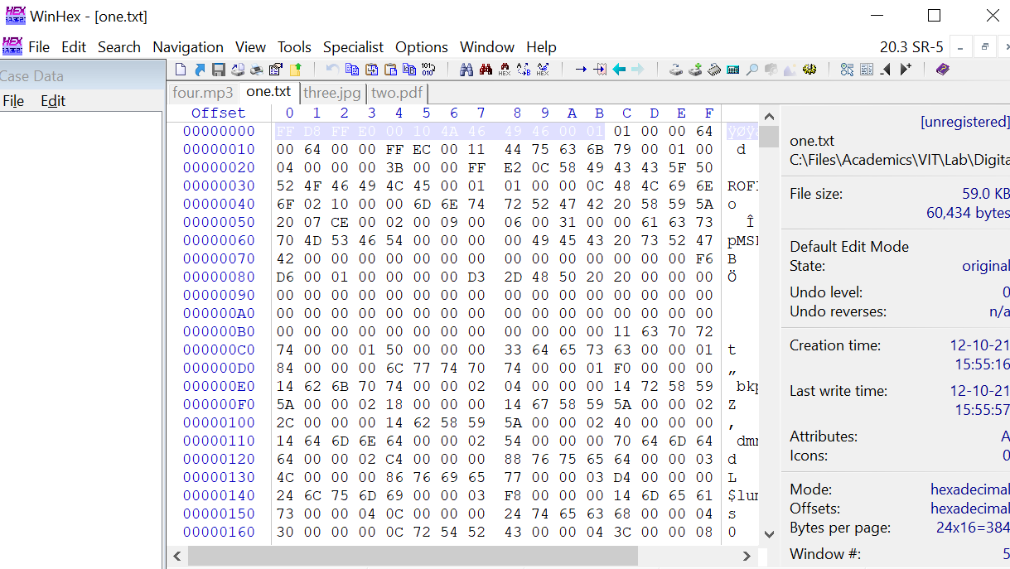



Header of another JFIF file

The file opened in the editor is named ‘one.txt’ and the File Explorer recognises it as a text file. But, when we open it with a hex editor, we see the header to have this Hex signature, (highlighted in the image above) which reads: FF D8 FF E0 00 10 4A 46 49 46 00 01.

This is the signature of a JFIF file. Hence, we now know that the file is actually a JFIF file. When checked with another JFIF file’s header they are the same, but the footers are different. This may be due to the fact that they have different content.

**two.png/.pdf**

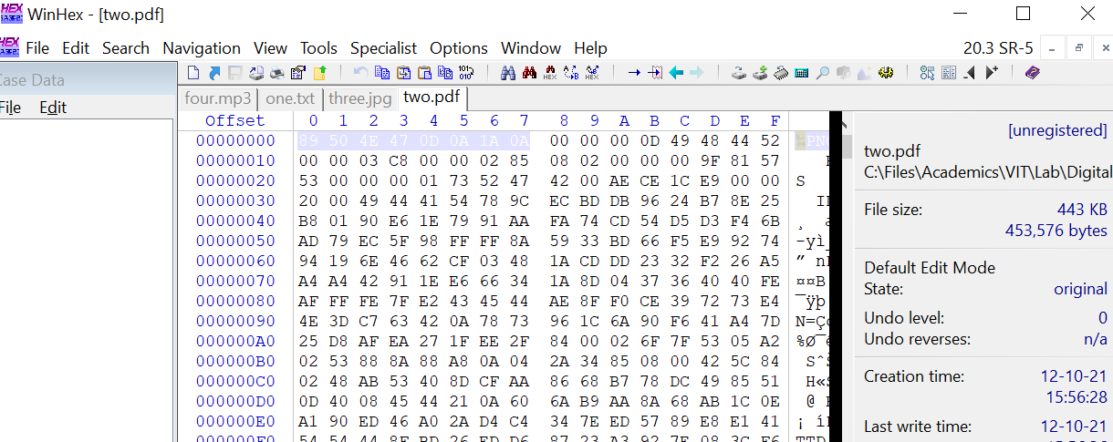

The file opened in the editor is named ‘two.pdf’ and the File Explorer recognises it as a PDF file. But, when we open it with a Hex editor, we see the header to have this Hex signature, (highlighted in the image above) which reads: 89 50 4E 47 0D 0A 1A 0A.

This is the signature of a PNG file and PDF has a different hex signature as we will see in a following output. Hence, we now know that the file is actually a PNG image file. When compared to the header of another PNG’s header, we see that they are matching.

**three.pdf/.jpg**

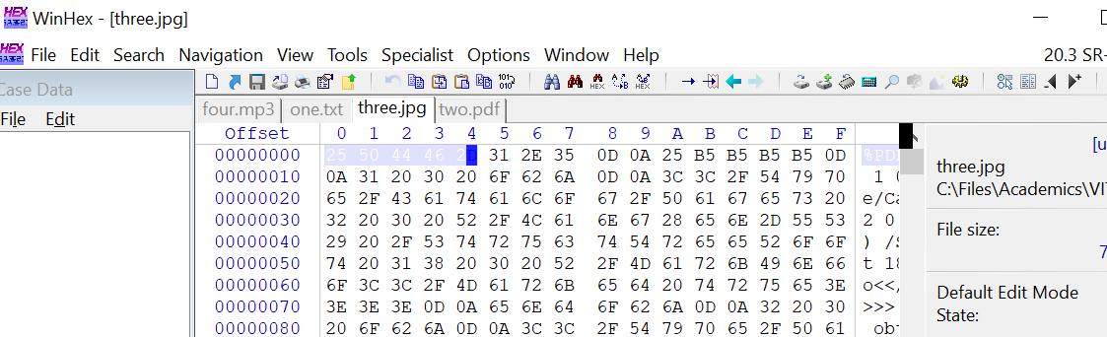

The file opened in the editor is named ‘three.jpg’ and the File Explorer recognises it as a JPG file. But, when we open it with a hex editor, we see the header to have this Hex signature, (highlighted in the image above) which reads: 25 50 44 46 2D.

This is the signature of a PDF file. Hence, we now know that the file is actually a PDF file.

**four.gif/.mp3**

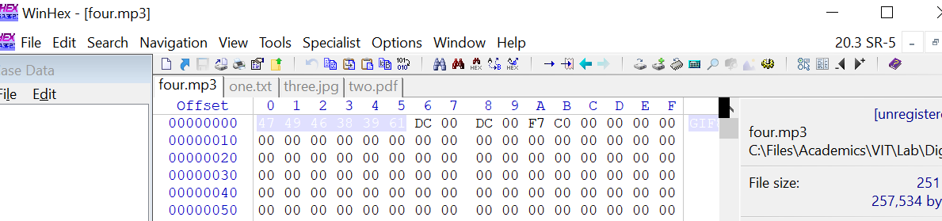

The file opened in the editor is named ‘four.mp3’ and the File Explorer recognises it as an MP3 file. But, when opened with an MP3 player, it doesn’t play the file and closes due to corrupt data. When we open it with a hex editor, we see the header to have this Hex signature, (highlighted in the image above) which reads: 47 49 46 38 37 61.

This is the signature of a GIF and MP3 has a different hex signature. Hence, we now know that the file is actually a GIF image.

**OBSERVATIONS**

Files of the same type always have the same file signatures in their header. This doesn’t change if the file’s extension is changed as their contents remain intact. The rest of the content excluding the header may vary for different files of the same type.

**CONCLUSION**

We now know how to identify file types with their header content which consists of their file signature. This is done with the help of a Hex editor such as win hex.